

* **Subject Name and Code:** **ICT726 Web Development**
* **Tutor Name:** Touseef RANA
* **Assessment Title:** **PetWalkers Technical Documentation**

**Academic Misconduct & Plagiarism Declaration**

We declare that this assessment is our own original work and complies with the **Academic Integrity Policy** of King’s Own Institute. We have not:

* Plagiarised the work of others (intentionally or unintentionally),
* Submitted work prepared by someone else or copied from unauthorised sources,
* Used unauthorised collaboration or assistance,
* Submitted this or similar work for credit in another subject without permission.

We understand that a breach of academic integrity may result in penalties including **failure of the assessment**, disciplinary action, or further institutional consequences.

**AI Use Acknowledgement & Disclosure**

We acknowledge that we have read and understood the subject’s **AI Use Guidelines**, including what is permitted, restricted, or prohibited in relation to generative AI tools.

We confirm that any AI use in this assessment:

* Follows the permitted uses outlined in the subject guidelines,
* Is properly cited using **Harvard** referencing,
* Is transparently disclosed below,
* Does not replace our own academic thinking or original writing,
* Is our sole responsibility, and we understand that **undisclosed or inappropriate use** may be a breach of academic integrity.

**AI Use Disclosure Table**

|  |  |  |
| --- | --- | --- |
| **AI Tool Used (e.g. ChatGPT, GrammarlyGO)** | **How It Was Used (brief description)** | **Why We Chose to Use It** |
| **Anthropic Claude** | **for content generation and design consultation. (Mentioned in Assessment 2 file)** |  |

☐We **did not** use any AI tools in the preparation of this assessment.  
✔️ We used AI tools as described above **in accordance with the subject’s AI Use Guidelines**.

**Student Declaration**

By signing below, we confirm that the information provided is accurate, and the work submitted complies with academic integrity standards.

|  |  |  |  |
| --- | --- | --- | --- |
| **Family Name** | **Given Name** | **Student ID** | **Signature** |
| Siwakoti | Razat | 20032655 | RS |
| Lama | Bijaya | 20033379 | BL |
| Bhusal | Milan | 20032881 | MB |

Academic Extension Approved ( New due data: 09/17 wednesday)

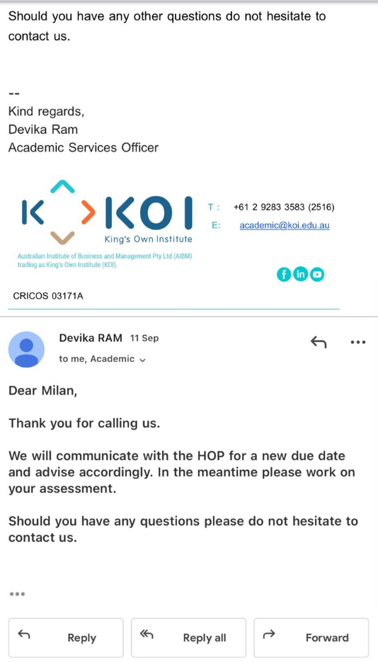

**PetWalkers United**

**Documentation Report**



**ICT726 Web Development**

**Submitted by: Group 10**

Razat Siwakoti (20032655)

Bijaya Lama (20033379)

Milan Bhusal (20032881)

Date: 09/16/2025

Instructor: Touseef RANA

GitHub link: [https://github.com/BijayLama11/petwalkers-united](https://github.com/BijayLama11/petwalkers-united%20)

clone repo:  
https://github.com/BijayLama11/petwalkers-united.git

**Table of Contents**

1. Introduction 1

2. Website Structure 1

3. Key Functionality Documentation 2

4. Key Functionality 3

4.1 User Authentication 3

4.1.1 Registration and Login Process 3

4.1.2 Multi-Level User Roles 3

4.1.3 Secure Password Management 4

5. Database Design and Implementation 5

5.1 Database Schema 5

5.2 Database Relationships 5

5.3 CRUD Operations Implementation 6

Create Operations: 6

Read Operations: 6

Update Operations: 6

Delete Operations: 6

5.4 Data Input Forms with Validation 7

Form 1: Contact Form (contact.php) 7

Form 2: User Registration (register.html) 7

6. Dynamic Web Desing Implementation 8

6.1 HTML5 and Semantic Structure 8

HTML5 Features 8

CSS3 Implementation 8

6.2 Error Handling and Validation 8

Client-Side Validation 8

Server-Side Validation 8

6.3 Responsiveness and Cross-Browser Compatibility 9

7. Web Standards Compliance 10

7.1 Accessibility Implementation 10

7.2 Usability Principles 10

7.3 Performance Optimization 10

8. Advanced SEO Implementation 12

8.1 Keyword Research and Strategy 12

8.2 On-Page SEO Strategies 12

9. Privacy and Security Implementation 9.1 Secure Data Handling Practices 13

9.2 Role-Based Access Control 13

9.3 Privacy Notice Implementation 13

10. Ethical Considerations and Academic Integrity 14

10.1 Ethical Web Development Practices 14

Data Privacy 14

User Rights 14

10.2 Academic Integrity Compliance 14

10.3 Documentation of Guidelines Adherence 15

11. Screenshots and Visuals 16

Admin Panel (Server Side) 16

Client side (Dynamic Pages) 19

12. Testing Logs 24

**List of Figures**

Figure 1 Admin Panel: Customer Enquries 16

Figure 2 Admin Panel:Manage Services 16

Figure 3Admin Panel:Manage User 17

Figure 4 Admin Panel: Manage Gallery 18

Figure 5 User Dashboard 19

Figure 6 Dynamic Gallery 20

Figure 7 Dynamic Contact Page 21

Figure 8 Dynamic Service Page 22

Figure 9 Adding new user form 23

**List of Tables**

Table 1: Database Setup Testing 24

Table 2: Authentication System Testing 25

Table 3: Admin Dashboard Testing 26

Table 4: Public Pages Testing 27

Table 5: Contact Form testing 28

Table 6: User Dashboard Testing 28

Table 7: Navigation & Security Testing 29

Table 8: Cross-Browser & Device Testing 29

Table 9: Integration and Dynamic Content Testing 30

Table 10: Error Handling and Edge cases 30

# 1. Introduction

PetWalkers United is a comprehensive web-based pet care service platform built with PHP, MySQL, HTML5, CSS3, and JavaScript. The system provides a complete solution for pet walking and sitting services, featuring user authentication, service management, contact handling, and administrative controls. This application demonstrates full-stack web development capabilities while adhering to modern web standards, security practices, and accessibility guidelines.

# 2. Website Structure

The website is dynamically designed with PHP as backend.

Overall Code Structure:

**petwalkers-united/**

├── **Frontend Layer**

│ ├── index.html **(Homepage with dynamic content)**

│ ├── about.html **(Company information)**

│ ├── contact.php **(Contact form with validation)**

│ ├── services.php **(Dynamic service listings)**

│ ├── gallery.php **(Photo gallery)**

│ ├── login.html **(Authentication interface)**

│ ├── register.html **(User registration)**

│ └── user-dashboard.php **(User account portal)**

│

├── **JavaScript Layer**

│ ├── js/main.js **(Core functionality and navigation)**

│ ├── js/auth.js **(Authentication handling)**

│ ├── js/form.js **(Form validation and submission)**

│ ├── js/gallery.js **(Gallery lightbox functionality)**

│ └── js/admin.js **(Administrative panel interactions)**

│

├── **Backend System**

│ ├── config/

│ │ └── db_config.php **(Database configuration)**

│ │

│ ├── modules/

│ │ ├── auth/ **(Authentication system)**

│ │ ├── admin/ **(Administrative functions)**

│ │ ├── contact/ **(Contact form processing)**

│ │ └── services/ **(Service management)**

│ │

│ ├── check_session.php (**Session validation)**

│ ├── logout.php **(Session** **termination)**

│ └── setup_database.php **(Database initialization)**

│

└── **Assets**

├── css/ **(Styling and responsive design)**

├── img/ **(Images and media files)**

└── documentation/ **(Project documentation)**

# 3. Key Functionality Documentation

**Authentication Flow:**

1. User registration through public form
2. Admin approval or automatic user role assignment
3. Login with email/password validation
4. Session creation and role-based redirection
5. Secure logout with session cleanup

**Content Management:**

1. Dynamic service display from database
2. Gallery image management with admin controls
3. Contact form processing and admin review
4. User management with role-based permissions

**Security Layers:**

1. Input validation and sanitization
2. SQL injection prevention
3. Session-based authentication
4. Role-based access control
5. Secure password handling

# 4. Key Functionality

## 4.1 User Authentication

### 4.1.1 Registration and Login Process

The application implements a robust authentication system with the following components:

**Registration Features:**

* Public user registration through register.html
* Comprehensive form validation (client and server-side)
* Automatic role assignment as 'user' for public registrations
* Email uniqueness verification
* Password strength requirements (minimum 6 characters)

**Login Features:**

* Secure login through login.html
* Session-based authentication using PHP sessions
* Password verification using password_verify()
* Role-based redirection (admin to dashboard, users to user portal)

### 4.1.2 Multi-Level User Roles

The system implements three distinct access levels:

**Admin Role:**

* Full administrative access to dashboard (backend/modules/admin/dashboard.php)
* Manage users, services, gallery, and contact submissions
* Create additional admin and user accounts
* Access to all CRUD operations

**User Role:**

* Access to personal dashboard (user-dashboard.php)
* Booking and inquiry capabilities
* Profile information viewing
* Limited to user-specific operations

**Public Access:**

* Browse services and gallery without authentication
* Submit contact forms
* Access to informational pages

### 4.1.3 Secure Password Management

* Passwords hashed using PHP's password_hash() with PASSWORD_DEFAULT
* No plain text storage in database
* Secure verification using password_verify()
* Session management with proper cleanup on logout

# 5. Database Design and Implementation

## 5.1 Database Schema

The application uses a well-structured MySQL database with four core tables:

**Users Table**

CREATE TABLE Users (

id INT(6) UNSIGNED AUTO_INCREMENT PRIMARY KEY,

first_name VARCHAR(50) NOT NULL,

last_name VARCHAR(50) NOT NULL,

email VARCHAR(100) NOT NULL UNIQUE,

phone VARCHAR(20) NOT NULL,

password VARCHAR(255) NOT NULL,

role ENUM('user', 'admin') DEFAULT 'user',

reg_date TIMESTAMP DEFAULT CURRENT_TIMESTAMP

);

**Services Table**

CREATE TABLE Services (

id INT(6) UNSIGNED AUTO_INCREMENT PRIMARY KEY,

service_name VARCHAR(100) NOT NULL,

subtitle TEXT NOT NULL,

description TEXT NOT NULL,

price DECIMAL(10, 2) NOT NULL,

last_updated TIMESTAMP DEFAULT CURRENT_TIMESTAMP

);

**Contact_Submissions Table**

CREATE TABLE contact_submissions (

id INT(6) UNSIGNED AUTO_INCREMENT PRIMARY KEY,

name VARCHAR(100) NOT NULL,

email VARCHAR(100) NOT NULL,

subject VARCHAR(255) NOT NULL,

message TEXT NOT NULL,

viewed TINYINT(1) DEFAULT 0,

submission_date TIMESTAMP DEFAULT CURRENT_TIMESTAMP

);

**Gallery_Images Table**

CREATE TABLE gallery_images (

id INT(6) UNSIGNED AUTO_INCREMENT PRIMARY KEY,

image_url VARCHAR(255) NOT NULL,

caption VARCHAR(255) NOT NULL,

upload_date TIMESTAMP DEFAULT CURRENT_TIMESTAMP

);

## 5.2 Database Relationships

* **Users to Contact_Submissions**: Logical relationship via email field
* **Services**: Standalone table for dynamic service management
* **Gallery_Images**: Independent image management system
* **Appropriate data types**: VARCHAR for text, DECIMAL for pricing, TIMESTAMP for dates

## 5.3 CRUD Operations Implementation

### Create Operations:

* User registration (backend/modules/auth/register.php)
* Service creation (backend/modules/admin/add_service.php)
* Contact form submissions (backend/modules/contact/process_contact_form.php)
* Gallery image additions (backend/modules/admin/add_gallery_image.php)

### Read Operations:

* Dynamic service display (services.php)
* Gallery image retrieval (gallery.php)
* User authentication verification
* Admin dashboard data display

### Update Operations:

* Contact submission status tracking
* User session management
* Service information modifications

### Delete Operations:

* Service removal (backend/modules/admin/delete_service.php)
* User account deletion (backend/modules/admin/delete_user.php)
* Contact submission management (backend/modules/admin/delete_contact.php)
* Gallery image removal (backend/modules/admin/delete_gallery_image.php)

## 5.4 Data Input Forms with Validation

### Form 1: Contact Form (contact.php)

**Validation Features:**

* Required field validation (name, email, service, date, time)
* Email format validation using regex
* Phone number format validation
* Date and time input validation
* Privacy consent requirement
* Server-side sanitization using real_escape_string

### Form 2: User Registration (register.html)

**Validation Features:**

* Password confirmation matching
* Email format and uniqueness checking
* Required field validation for all inputs
* Phone number format validation
* Client-side and server-side validation coordination

# 6. Dynamic Web Desing Implementation

## 6.1 HTML5 and Semantic Structure

### HTML5 Features

* Semantic elements (<header>, <nav>, <main>, <section>, <article>)
* Form input types (email, tel, date, time)
* ARIA roles and labels for accessibility
* Proper document structure and meta tags

### CSS3 Implementation

* Responsive grid layouts using CSS Grid and Flexbox
* Custom CSS variables for consistent theming
* Modern styling with transitions and hover effects
* Mobile-first responsive design approach

## 6.2 Error Handling and Validation

### Client-Side Validation

* Real-time form validation with JavaScript
* Visual feedback for validation errors
* Custom notification system with success/error messages
* Input sanitization and format checking

### Server-Side Validation

* Comprehensive PHP validation functions
* Database constraint handling
* Error response management with proper HTTP codes
* Input sanitization and SQL injection prevention

## 6.3 Responsiveness and Cross-Browser Compatibility

* Mobile-responsive design using CSS media queries
* Flexible layouts adapting to different screen sizes
* Cross-browser compatible CSS properties
* Progressive enhancement approach
* Touch-friendly navigation for mobile devices

# 7. Web Standards Compliance

## 7.1 Accessibility Implementation

PetWalkers United strictly adheres to accessibility standards to ensure all users can navigate and interact with the website effectively. Semantic HTML is used consistently, with proper heading hierarchies from <h1> to <h6> to organize content and enhance screen reader interpretation. All links contain descriptive text, and form labels are explicitly associated with their respective inputs, providing clarity and ease of use. Skip links are implemented to facilitate keyboard navigation, allowing users to bypass repetitive content. ARIA roles and attributes supplement the semantic structure, with role attributes applied to navigation and content sections, aria-label and aria-describedby for form elements, aria-current to indicate active navigation states, and aria-live regions for dynamic content updates, ensuring that users with assistive technologies receive timely information.

## 7.2 Usability Principles

The website’s usability is designed for intuitive navigation and clear interaction flows. Navigation is consistent across all pages, with a clear visual hierarchy guiding the user from landing pages to specific actions. Forms are user-friendly, providing helpful feedback and instructions for errors, ensuring smooth interaction. Dynamic navigation adapts based on user authentication status, presenting context-specific options. Additionally, confirmation dialogs are presented for any destructive actions to prevent accidental changes, while loading states and visual feedback enhance user awareness of system responses. These measures collectively create a seamless and accessible experience for all visitors, including both authenticated users and public access.

## 7.3 Performance Optimization

Performance optimization is integrated throughout the platform. Images are stored in appropriate formats and sizes to balance quality and loading speed, with lazy loading implemented to reduce initial load times. Galleries are optimized using thumbnails, and fallback mechanisms are provided for missing images. Code efficiency is achieved through minified CSS and JavaScript files, optimized database queries using prepared statements, and proper caching headers to reduce server load and improve response times. The file structure is organized to facilitate efficient resource retrieval, contributing to overall faster page rendering and enhanced user experience across devices.

# 8. Advanced SEO Implementation

**8.1 Keyword Research and Strategy**

The platform employs a targeted SEO strategy to improve discoverability and local search relevance. Primary keywords include "pet walking services Sydney," "professional pet sitting," "dog walking NSW," "reliable pet care," and "local pet services," while long-tail keywords such as "trusted pet walking services near me," "professional dog walking Sydney," and "reliable pet sitting services" capture specific search intents. These keywords are strategically integrated into content, headings, and meta descriptions to improve search engine visibility without compromising natural content flow.

**8.2 On-Page SEO Strategies**

On-page SEO is systematically applied to maximize search engine performance. Unique title tags are implemented for each page with relevant target keywords, while meta descriptions are concise, descriptive, and limited to under 160 characters. Meta viewport tags are used to optimize mobile display, and a favicon is included for brand recognition. HTML heading tags follow a proper H1-H6 hierarchy, incorporating keywords where appropriate. All images contain descriptive alt text, and schema.org markup is applied where relevant to provide structured data for local business searches. Internal linking is carefully structured to facilitate navigation and improve content discoverability. Service-specific landing pages, location-based content, and customer testimonials are also incorporated to strengthen relevance, trust, and authority in search rankings.

9. Privacy and Security Implementation9.1 Secure Data Handling Practices

The platform prioritizes secure handling of sensitive user data. Passwords are hashed using PHP’s password_hash() function with the PASSWORD_DEFAULT algorithm, ensuring that no plain text passwords are stored. Password verification is performed securely using password_verify(). All user inputs undergo server-side validation, protecting against SQL injection through the use of prepared statements and mitigating XSS attacks with output escaping. CSRF considerations are also integrated to enhance security. Session management follows best practices, including secure configuration, proper cleanup upon logout, session timeout implementation, and enforcement of role-based access control, preventing unauthorized access to restricted areas.

## 9.2 Role-Based Access Control

Role-based access control ensures that users interact only with functions appropriate to their assigned role. Administrators are protected by session checks that verify both login status and role before granting access to sensitive functionalities. If an unauthorized user attempts access, they are redirected automatically to the login page. Standard users undergo similar session validation for protected pages, and any attempts to bypass access controls are mitigated by automatic redirection. Logout functionality is implemented thoroughly, destroying sessions to prevent lingering access tokens and unauthorized use.

**Admin Protection**

if (!isset($_SESSION['loggedin']) ||

$_SESSION['loggedin'] !== true ||

$_SESSION['role'] !== 'admin') {

header("Location: /login.html");

exit;

}

## 9.3 Privacy Notice Implementation

PetWalkers United maintains transparency in data collection and processing. Users are informed clearly about the types of data collected and the purposes for which it will be used, with consent required for all form submissions. Privacy notices are linked within the contact form and throughout the website to ensure visibility. Data protection measures include secure database storage, limited retention policies, user-initiated data deletion, and secure transmission protocols. These practices collectively uphold user privacy and maintain compliance with standard web security and privacy expectations.

# 10. Ethical Considerations and Academic Integrity

## 10.1 Ethical Web Development Practices

Data Privacy  
The platform collects only the essential information required to provide services. Clear consent mechanisms are implemented for all forms, ensuring users understand what data is collected and how it is used. Privacy policies are transparent and accessible, and all data is stored securely to prevent unauthorized access.

User Rights  
Users have the right to request deletion of their personal data at any time. Terms of service are clearly communicated, with no deceptive practices employed. All services are represented honestly, reflecting the true functionality of the platform.

## 10.2 Academic Integrity Compliance

**Original Development**

* All code written specifically for this project
* No copying of existing commercial platforms
* Proper attribution of any external resources
* Original design and functionality concepts

**External Resources Used**

* Font Awesome 4.7.0 for icons (properly attributed)
* Standard web technologies (HTML5, CSS3, JavaScript, PHP)
* No proprietary code or copyrighted materials

## 10.3 Documentation of Guidelines Adherence

**Requirement Compliance**  
All specified functionalities were implemented. The database design follows relational principles. Security best practices, accessibility guidelines, and SEO techniques were properly applied.

**No Deviations**  
All project requirements were met as specified. There were no significant changes from the original guidelines. The implementation of requested features is complete.

# 11. Screenshots and Visuals

## Admin Panel (Server Side)

- View and delete customer enquiries

Figure 1 Admin Panel: Customer Enquries

- Add or delete service

Figure 2 Admin Panel:Manage Services

- Add or remove users/admin

Figure 3Admin Panel:Manage User

- Add or delete images to display in gallery

Figure 4 Admin Panel: Manage Gallery

## Client side (Dynamic Pages)

User dashboard:

- See owns personal and other information (Booking, Services etc)

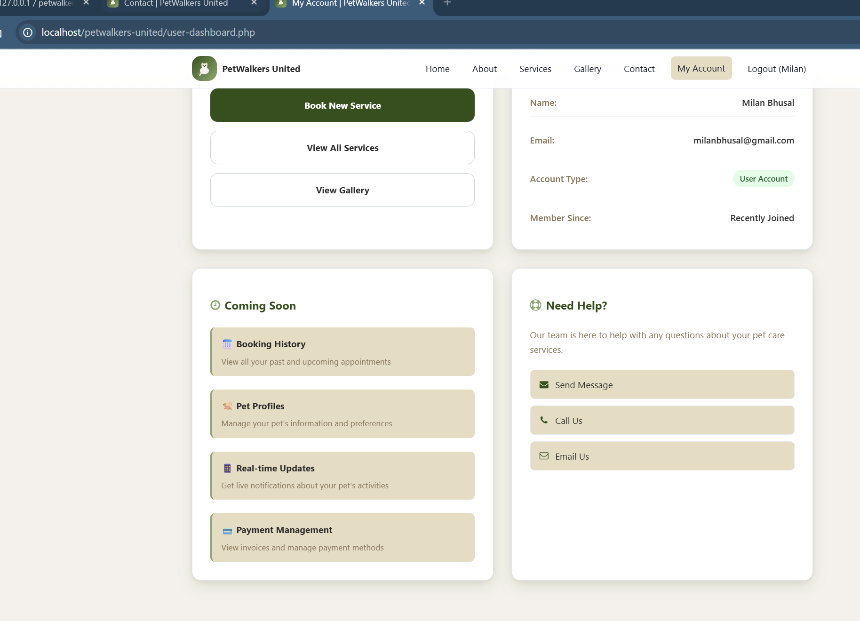

Figure 5 User Dashboard

Dynamic Gallery Page

- Display picture only added by admin (not hard coded picture)

Figure 6 Dynamic Gallery

Contact Page  
- Display new service added by admin as well

Figure 7 Dynamic Contact Page

Services Page:  
- Show available service only (can be changed by admin)

Figure 8 Dynamic Service Page

Register page

- Checks and register new people as users and add them to database

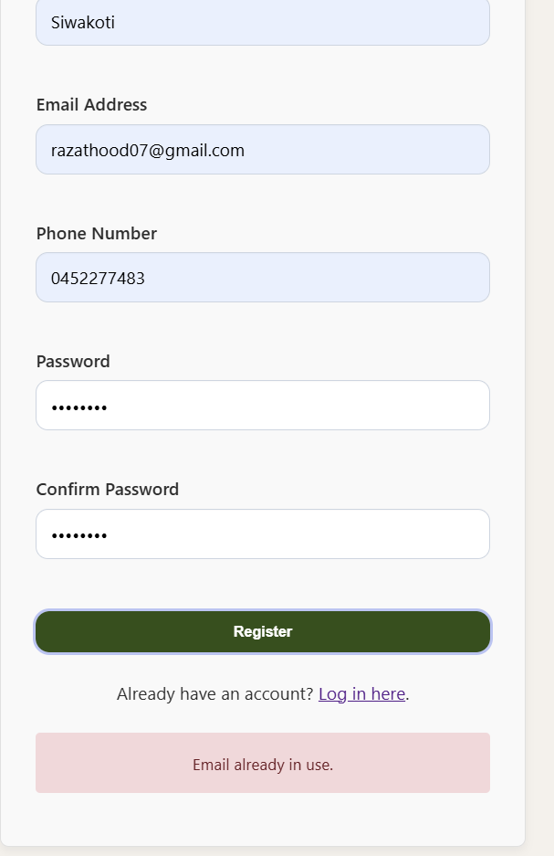

Figure 9 Adding new user form

# 12. Testing Logs

Table 1: Database Setup Testing

|  |  |  |  |
| --- | --- | --- | --- |
| **Test ID** | **Testing** | **Description** | **Result** |
| DB-001 | Database Creation | Run backend/setup_database.php to create database and tables |  |
| DB-002 | Table Structure | Verify all tables (users, services, contact_submissions, gallery_images) exist |  |
| DB-003 | Default Admin Account | Check default admin account exists (20033379@students.koi.edu.au / admin123) |  |
| DB-004 | Database Connection | Run test_db_connection.php to verify connectivity |  |
| DB-005 | Services Table Update | Run update_services_table.php to add subtitle column |  |

Table 2: Authentication System Testing

|  |  |  |  |
| --- | --- | --- | --- |
| **Test ID** | **Testing** | **Description** | **Result** |
| AUTH-001 | User Registration - Valid Data | Register with all required fields filled correctly |  |
| AUTH-002 | User Registration - Duplicate Email | Try registering with existing email address |  |
| AUTH-003 | User Registration - Password Mismatch | Register with non-matching passwords |  |
| AUTH-004 | User Registration - Empty Fields | Submit registration form with missing required fields |  |
| AUTH-005 | User Registration - Database Check | Verify new user appears in database with 'user' role |  |
| AUTH-006 | Login - Valid Admin Credentials | Login with admin email/password |  |
| AUTH-007 | Login - Valid User Credentials | Login with regular user email/password |  |
| AUTH-008 | Login - Invalid Credentials | Login with wrong email/password combination |  |
| AUTH-009 | Login - Empty Fields | Submit login form with empty fields |  |
| AUTH-010 | Login - Role Redirection | Verify admin goes to dashboard, user goes to user-dashboard |  |
| AUTH-011 | Logout Functionality | Click logout and verify redirect to login page |  |
| AUTH-012 | Session Protection | Try accessing protected pages after logout |  |

|  |  |  |  |
| --- | --- | --- | --- |
| **Test ID** | **Testing** | **Description** | **Result** |
| ADM-001 | Admin Access Control | Access admin dashboard with admin credentials |  |
| ADM-002 | User Access Denied | Try accessing admin dashboard with user credentials |  |
| ADM-003 | Contact Submissions View | Submit contact form and verify it appears in admin dashboard |  |
| ADM-004 | Contact Submission Delete | Delete a contact submission from admin panel |  |
| ADM-005 | Services Management Access | Navigate to manage_services.php |  |
| ADM-006 | Add New Service | Add service with all fields (name, subtitle, description, price) |  |
| ADM-007 | Service Validation | Try adding service with empty required fields |  |
| ADM-008 | Service Display | Verify new service appears in services table |  |
| ADM-009 | Delete Service | Remove a service and verify deletion |  |
| ADM-010 | User Management Access | Navigate to manage_users.php |  |
| ADM-011 | Add New User - Regular | Add user with 'user' role |  |
| ADM-012 | Add New Admin | Add user with 'admin' role |  |
| ADM-013 | User Duplicate Email | Try adding user with existing email |  |
| ADM-014 | User Weak Password | Try adding user with password less than 6 characters |  |
| ADM-015 | Delete User | Delete a user (not current admin) |  |
| ADM-016 | Self-Delete Prevention | Try to delete own admin account |  |
| ADM-017 | Gallery Management Access | Navigate to manage_gallery.php |  |
| ADM-018 | Add Gallery Image - Local | Add image with local path (img/gallery/...) |  |
| ADM-019 | Add Gallery Image - URL | Add image with external URL |  |
| ADM-020 | Gallery Image Validation | Try adding image with invalid URL format |  |
| ADM-021 | Delete Gallery Image | Remove an image from gallery |  |

Table 3: Admin Dashboard Testing

Table 4: Public Pages Testing

|  |  |  |  |
| --- | --- | --- | --- |
| **Test ID** | **Testing** | **Description** | **Result** |
| ADM-001 | Admin Access Control | Access admin dashboard with admin credentials |  |
| ADM-002 | User Access Denied | Try accessing admin dashboard with user credentials |  |
| ADM-003 | Contact Submissions View | Submit contact form and verify it appears in admin dashboard |  |
| ADM-004 | Contact Submission Delete | Delete a contact submission from admin panel |  |
| ADM-005 | Services Management Access | Navigate to manage_services.php |  |
| ADM-006 | Add New Service | Add service with all fields (name, subtitle, description, price) |  |
| ADM-007 | Service Validation | Try adding service with empty required fields |  |
| ADM-008 | Service Display | Verify new service appears in services table |  |
| ADM-009 | Delete Service | Remove a service and verify deletion |  |
| ADM-010 | User Management Access | Navigate to manage_users.php |  |
| ADM-011 | Add New User - Regular | Add user with 'user' role |  |
| ADM-012 | Add New Admin | Add user with 'admin' role |  |
| ADM-013 | User Duplicate Email | Try adding user with existing email |  |
| ADM-014 | User Weak Password | Try adding user with password less than 6 characters |  |
| ADM-015 | Delete User | Delete a user (not current admin) |  |
| ADM-016 | Self-Delete Prevention | Try to delete own admin account |  |
| ADM-017 | Gallery Management Access | Navigate to manage_gallery.php |  |
| ADM-018 | Add Gallery Image - Local | Add image with local path (img/gallery/...) |  |
| ADM-019 | Add Gallery Image - URL | Add image with external URL |  |
| ADM-020 | Gallery Image Validation | Try adding image with invalid URL format |  |
| ADM-021 | Delete Gallery Image | Remove an image from gallery |  |

Table 5: Contact Form testing

|  |  |  |  |
| --- | --- | --- | --- |
| **Test ID** | **Testing** | **Description** | **Result** |
| FORM-001 | Contact Form Load | Access contact.php and verify form displays |  |
| FORM-002 | Service Dropdown Population | Verify services dropdown loads from database |  |
| FORM-003 | Required Field Validation | Submit form with missing required fields |  |
| FORM-004 | Email Format Validation | Submit form with invalid email format |  |
| FORM-005 | Phone Number Validation | Test phone number pattern validation |  |
| FORM-006 | Date/Time Selection | Test date and time input fields |  |
| FORM-007 | Successful Submission | Submit complete valid form |  |
| FORM-008 | Success Message Display | Verify success notification appears |  |
| FORM-009 | Admin Dashboard Integration | Check submission appears in admin panel |  |
| FORM-010 | Form Reset | Test reset button functionality |  |
| FORM-011 | Character Limits | Test message field maximum length |  |
| FORM-012 | Special Characters | Submit form with special characters in fields |  |

Table 6: User Dashboard Testing

|  |  |  |  |
| --- | --- | --- | --- |
| **Test ID** | **Testing** | **Description** | **Result** |
| USER-001 | User Dashboard Access | Login as user and access user-dashboard.php |  |
| USER-002 | User Info Display | Verify user's name and email display correctly |  |
| USER-003 | Quick Action Links | Test all quick action buttons/links |  |
| USER-004 | Support Contact Options | Test support contact links |  |
| USER-005 | Admin Access Block | Verify admin can't access user dashboard inappropriately |  |
| USER-006 | Coming Soon Features | Verify coming soon section displays |  |

Table 7: Navigation & Security Testing

|  |  |  |  |
| --- | --- | --- | --- |
| **Test ID** | **Testing** | **Description** | **Result** |
| NAV-001 | Dynamic Navigation - Logged Out | Check navigation shows Login link when not logged in |  |
| NAV-002 | Dynamic Navigation - User | Check navigation shows My Account when logged in as user |  |
| NAV-003 | Dynamic Navigation - Admin | Check navigation shows Admin Panel when logged in as admin |  |
| NAV-004 | Mobile Menu Toggle | Test hamburger menu functionality on mobile |  |
| NAV-005 | Breadcrumb Navigation | Test aria-current="page" indicators |  |
| SEC-001 | Admin URL Protection | Try accessing admin URLs without login |  |
| SEC-002 | User Role Enforcement | Try accessing admin features as regular user |  |
| SEC-003 | Session Timeout | Test behaviour when session expires |  |
| SEC-004 | SQL Injection Prevention | Test login forms with SQL injection attempts |  |
| SEC-005 | XSS Prevention | Test forms with JavaScript injection attempts |  |
| SEC-006 | Password Hashing | Verify passwords are hashed in database |  |

Table 8: Cross-Browser & Device Testing

|  |  |  |  |
| --- | --- | --- | --- |
| **Test ID** | **Testing** | **Description** | **Result** |
| CROSS-001 | Chrome Desktop | Test all functionality in Chrome |  |
| CROSS-002 | Firefox Desktop | Test all functionality in Firefox |  |
| CROSS-003 | Safari Desktop | Test all functionality in Safari |  |
| CROSS-004 | Edge Desktop | Test all functionality in Edge |  |
| CROSS-005 | iOS Safari Mobile | Test responsive design on iPhone Safari |  |
| CROSS-006 | Android Chrome Mobile | Test responsive design on Android Chrome |  |
| CROSS-007 | Tablet Layout | Test layout on iPad/Android tablet |  |
| CROSS-008 | Mobile Form Input | Test form inputs on mobile devices |  |

Table 9: Integration and Dynamic Content Testing

|  |  |  |  |
| --- | --- | --- | --- |
| **Test ID** | **Testing** | **Description** | **Result** |
| INT-001 | Service Add → Contact Form | Add service in admin, check appears in contact dropdown |  |
| INT-002 | Service Delete → Contact Form | Delete service, verify removal from contact dropdown |  |
| INT-003 | Gallery Add → Public Page | Add image in admin, check appears on gallery.php |  |
| INT-004 | Gallery Delete → Public Page | Delete image, verify removal from gallery.php |  |
| INT-005 | Contact Submit → Admin View | Submit contact form, verify in admin dashboard |  |
| INT-006 | User Add → User Table | Add user in admin, verify appears in user management |  |
| INT-007 | Services → Public Display | Add service, verify correct display on services.php |  |
| INT-008 | Real-time Updates | Test multiple admin actions and verify frontend updates |  |

Table 10: Error Handling and Edge cases

|  |  |  |  |
| --- | --- | --- | --- |
| **Test ID** | **Testing** | **Description** | **Result** |
| ERR-001 | Database Connection Loss | Test behavior when database connection fails |  |
| ERR-002 | Missing Image Files | Test gallery with broken image paths |  |
| ERR-003 | Large File Uploads | Test image uploads with very large files |  |
| ERR-004 | Long Text Input | Test with very long descriptions/messages |  |
| ERR-005 | Special Character Handling | Test with emojis and special characters |  |
| ERR-006 | Network Timeout | Test form submissions with slow network |  |
| ERR-007 | JavaScript Disabled | Test basic functionality with JS disabled |  |
| ERR-008 | CSS Loading Failure | Test page usability when CSS fails to load |  |